ESSEX METROPOLITAN NETBALL ASSOCIATION
Under 13
County Academies Trials

Saturday 17th September 2022 at Redbridge Sports centre
09.30am – 3.00pm

Monday 19th September 2022 at Redbridge Sports Centre
6pm-8pm

Year 6, 7 & 8
Redbridge Sports Centre
Forest Road
Ilford
IG6 3HD

You must be available to trial on both days.
Notice of successful athletes will be placed on the Essex Met Website.
Date to be confirmed.
Link closes Tuesday 6th September 2022 at 11.59pm.
No late applicants will be accepted.
Please complete the Google Form link below.
https://docs.google.com/forms/d/e/1FAIpQLSdLpidMkTLsnOboxn47cDvwvo_28rtNxt2Xzlc9AFv_aWY29w/viewform

Or scan the QR Code

More information please email: essexmetcounty@gmail.com

Trial fee is £10

We request that you complete a BACS transfer.
Co-Op 08-92-99
65422500
Essex Metropolitan Netball Association
(Please place your Childs name as reference on bacs transfer)

Please note
Playing Kit for the trials – navy blue or black skirt/shorts and white t-shirt. NO CLUB KIT or SCHOOL KIT Allowed
(In the case of religious/cultural reasons leggings are permitted)

Training will be held every other week excluding half terms from 6.00pm-8.00pm at Redbridge Sports Centre on the indoor and/or outdoor courts.
There may be a netball Festival in March 2023.

Essex Met Academy Fee for this season is £240 which includes a T-Shirt, entry to festival and Ball.
London Pulse Fee to be confirmed

Please note that all successful athletes MUST be registered via England Netball for Season 2022/2023 either via their netball club, school or parent on Engage

Become a Member on Engage

https://www.englandnetball.co.uk/membership/become-a-member/junior-member-benefits/

There is much confusion regarding the future of the Performance Pathway and this brief document seeks to provide clarification. More information can found at https://www.englandnetball.co.uk/the-roses-development-framework/player-pathway/

Principles of the pathway change are:

To achieve England Netball's vision of having the world's most successful Performance Pathway. To produce World Class players, who strive for excellence and live & breathe a 'Netball First' culture. A greater alignment between the pathway and talent development.

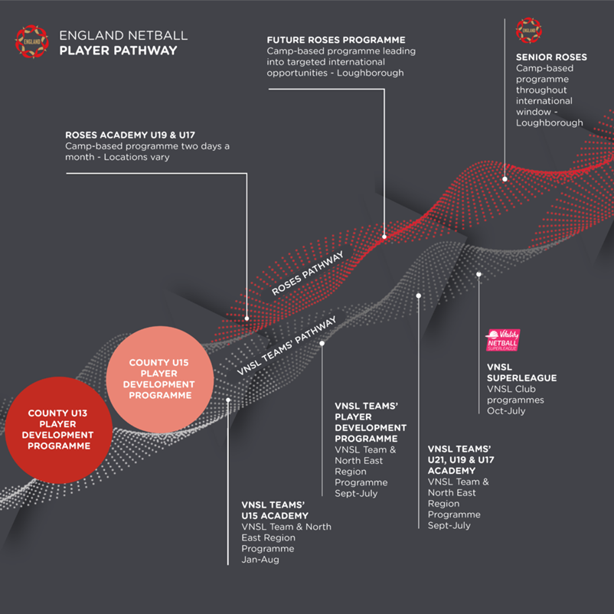

Each County Academy and VNSL Team will organise trials and identify 20 athletes for each of the Player Pathway Programmes.

– Under-15 athletes may trial for and attend any County Player Development Programme in any county, in order to provide choice for parents and athletes.

– Under-15 athletes must be allowed to screen for and, if successful, have a place within the County Player Development Programme.

– Exceptional Under-15 Athletes can attend trials and be selected for VNSL Teams’ Academy Programme or the VNSL Team’s Player Development Programme if their nomination/selection was approved by the County Player Development Lead and the Franchise Pathway Lead of the VNSL Team to which the County is assigned.

VNSLTeams Under15 Academy Selection -Stage 1

December 2022 /January 2023

Only Under-15 athletes from County Player Development Programmes within VNSL Team’s assigned territory can be selected for the VNSL Teams’ Under-15 Academies at this stage.
Selected athletes for VNSL Teams’ Under-15 Academy stay with their County Player Development Programmes and continue to attend training sessions in both programmes till May 2023.

VNSLTeams Under15 Academy Selection -Stage 2

At this stage the VNSL Teams’ Under-15 Academies can select:

– Any Under-15 athletes who attended any County Player Development Programme (it could be from different assigned territory), and who are registered on Engage by 31st March 2023
– Any Under-15 athletes from within The VNSL Teams’ player pathway programmes (Under-19 Academy, Under-17 Academy or Player Development programme) who are registered on ENgage by 31st March 2023

July/August 2023 VNSL Teams Under 15 Academy Team Selection

VNSL Teams’ Under-15 Academies select final 12 athletes who are competing on the School Games National Finals 2023.

September 2023 School Games National Finals

Youth Sport Trust is hosting the School Games National Finals as a multisport event. England Netball use the School Games National Finals as the opportunity to tell the full story of what it takes to be game ready and celebrate the resilience of our young athletes. Over three days netball competition between VNSL Teams’ Under-15 Academy Teams provide an opportunity for England Netball selectors to observe and select additional athletes for the Roses Academy programme.

Emergency contact on the day of trials is
Michelle Cox Head Coach 07985 251235
Tracy Howe Essex Met Team Manager 07970 458238
Or email: Essexmetcounty@gmail.com

