Netball Europe Umpiring C Award Online Paper

The Netball Europe (NE) C Award Online Paper process is detailed in this document. You can navigate to each part of the process by clicking on the links below.
At the bottom of each section is a link to bring you back to this page.

Application Process

OneFile Registration Process

Starting the Online Paper

NE C Award Online Paper

Hints and Tips

Copyright © Netball Europe 2020
All rights reserved. This publication may not be copied or reproduced in whole or in part or stored in any medium, without the prior consent of Netball Europe.

Images reprinted with permission of OneFile Ltd (OneFile).

Application Process

To apply for your C Award Online Paper please refer to the instructions given on the Officiating Section of your Country’s website.

The Netball Europe C Award Online Paper Administrator (the Administrator) can be contacted at netballeuropeca@outlook.com .

Return to top
OneFile Registration Process

Once you have applied to take the Netball Europe C Award Online Paper you will be registered on OneFile and as a result you should receive an email invitation with a hyperlink from alert@onefile.co.uk . Sometimes these emails are directed to your junk mail folder so please check there if you do not receive an email. This link is valid for 7 days.

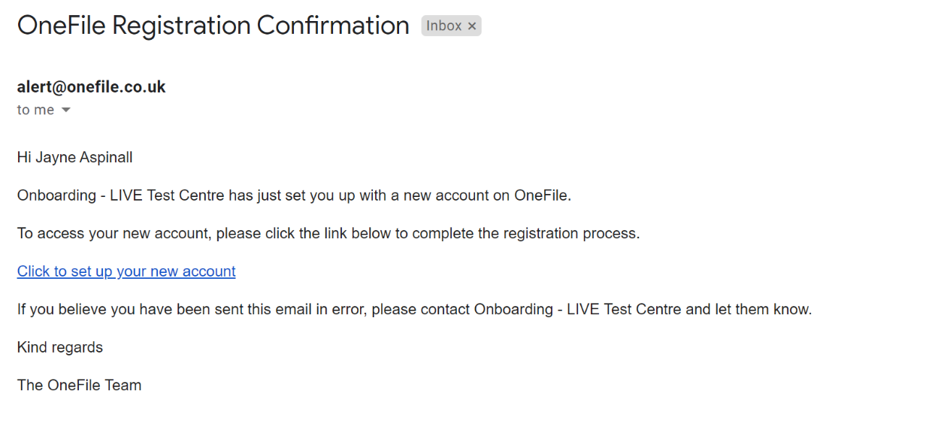

1 OneFile Email

Once you have received the email click on the link Click to set up your new account.

At the link you will be asked to produce a password. This password will also be valid for 7 days.

Please complete your registration by providing a password to access your account created by Netball Europe.
Please observe the password rules when choosing your password.
- Your password must be at least 10 characters
- But it must be no more than 128 characters
- It must contain at least 1 number
- It must contain at least 1 letter
- All passwords are case-sensitive
- Special characters are allowed
Once you have your password click on the Register button.

You should see the following screen:

2 Registration Complete

Click on the Continue to login…. Button.

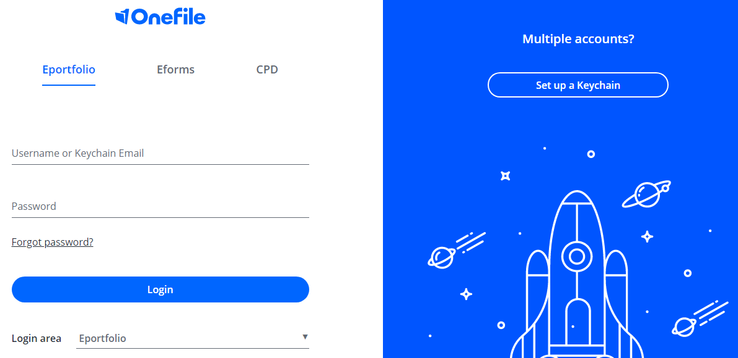

3 OneFile Login screen
Enter your email and password and press Login button.

Check your personal details are correct. Read and agree to the terms and conditions and then click on Save.

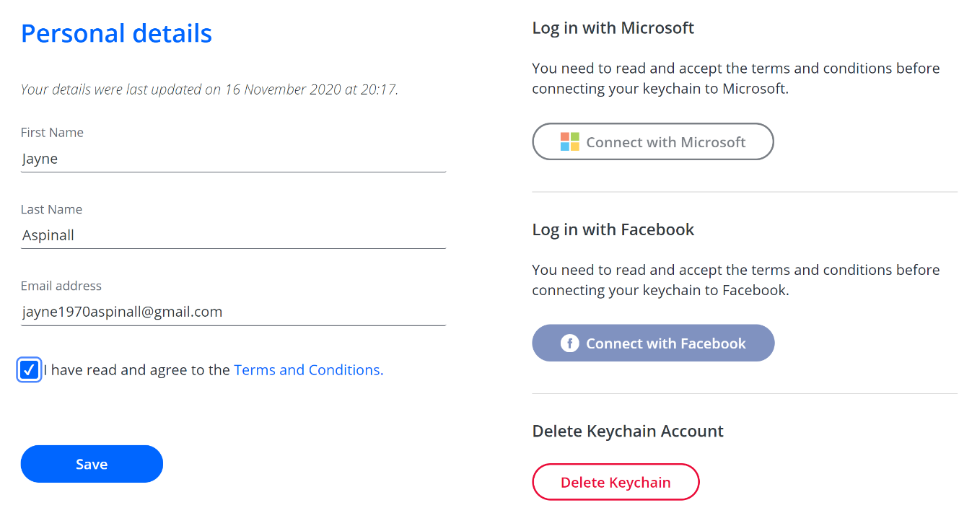

4 OneFile Personal Details

On the next screen select Eportfolio button

5 OneFile My Account screen

At the next screen scroll to the bottom and click I Agree button.

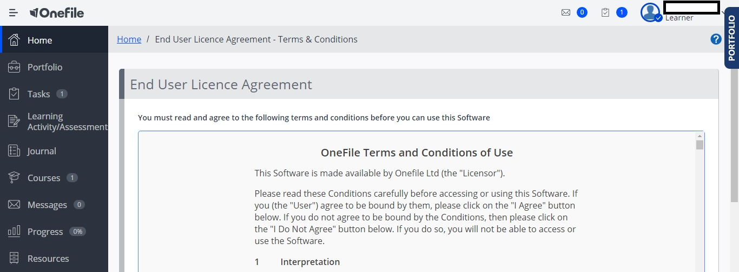

6 OneFile End User Licence Agreement

The next screen invites you to help them improve OneFile. This is up to you! Click on the relevant button for yourself.

7 OneFile Improvement screen

On the next screen click on Go to Eportfolio button

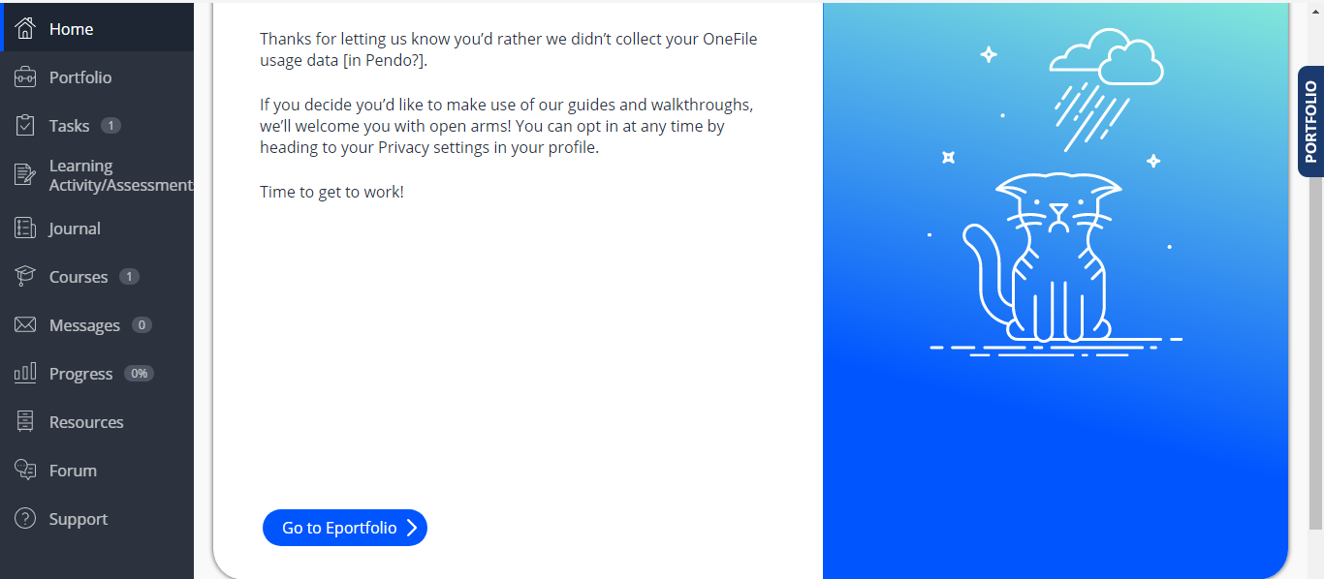

8 OneFile Go to Eportfolio screen

If there are any software maintenance notifications check that they won’t interfere with your planned use timings and click the Continue button.

Return to top
Starting the Online Paper

On the next screen click on Courses button

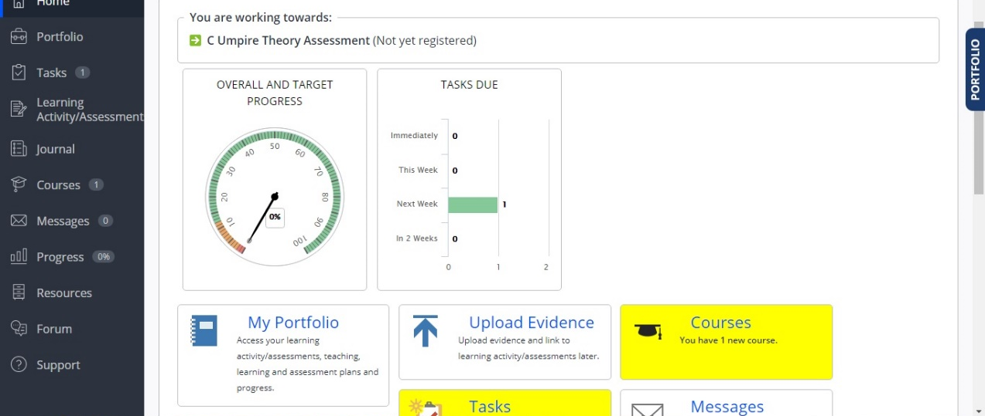

9 OneFile Portfolio Dashboard

Click on the START COURSE button

10 OneFile Start Course

Select Start Course button

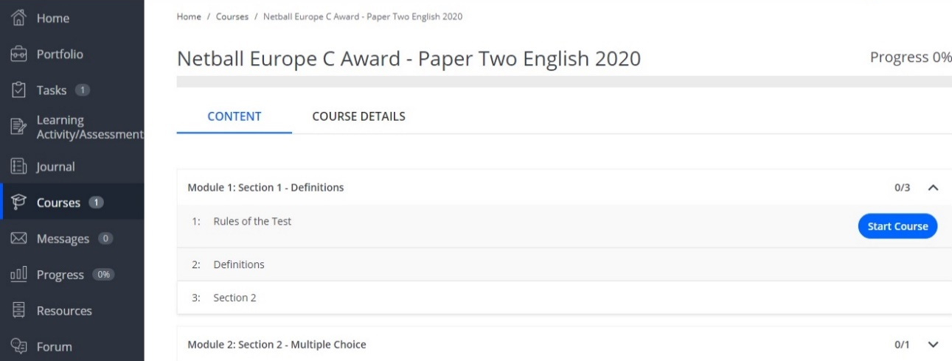

11 OneFile Actual Paper
The next screen is the Rules of the Test. Note that you have 30 minutes to complete the Test and if you do exceed that time limit the Administrator may class your result as Not Yet Met Competency.
You have 30 minutes to complete this paper, as measured on the OneFile clock. This clock is visible on your screen in Section 1 only, in Section 2 it reverts to an internal clock.

If you are still in Section 1 at the end of the 30 minutes, your screen will freeze preventing any further action by you. In this case you will be assessed as Not Yet Met Competency (NYMC). If you are in Section 2 the screen will not freeze and you will be able to answer all questions. The Administrator will check your timing to check if you had correctly answered a minimum of three Section 2 questions within the time limit. If you were successful you will be awarded a Pass, if not, you will be assessed as NYMC.

Be aware that the questions in Section 2 can be either a direct question for you to answer, a scenario for you to resolve, or a statement of fact for you to judge. Select from the 3 options the one that meets the requirements of the question.

12 OneFile Rules of the Test
From this point onwards you will be in the actual paper.

Return to top
NE C Award Online Paper

The Paper is in two parts, Section 1 and Section 2.

Section 1 has 25 questions where the answer is either True or False.

Section 2 has 5 Multi-choice questions which have 3 options. Only one of the options is correct. Be aware that these questions can be either a direct question for you to answer, a scenario for you to resolve, or a statement of fact for you to judge. Select from the 3 options the one that meets the requirements of the question.

The pass mark for Section 1 is a minimum of 21 out of 25 and for Section 2 is a minimum of 3 out of 5.

You will have a maximum time limit of 30 minutes to complete both Sections. This timing is on a visible clock on the screen, in Section 1 only, which will count down from 30 minutes. In Section 2 the clock is no longer visible and reverts to the internal clock.

13 Visible Countdown Clock
14 Clock Shown Under Question
At the end of 30 minutes, if still in Section 1, your paper will freeze, you will not be able to go forward or backwards.

If Section 1 successfully completed the Administrator will check your score in Section 2 –
- Score 3 or 4 out of 5 then Pass awarded – you and your Country informed
- Score less than 3 out of 5 – NYMC – Contact Administrator at netballeuropeca@outlook.com

If Section 1 not successfully completed – NYMC – Contact Administrator at netballeuropeca@outlook.com

Each question in both Sections must be answered in order. The system will not let you move on to the next question until you have entered an answer.

The system marks the paper as you progress and will give you the result for Section 1 immediately on answering the 25th question. If successful you will move onto Section 2. If successful in Section 2 you will be informed of the result by the system. The result will be registered with Netball Europe and your Country administration will be informed of the result by the Administrator.

If unsuccessful in Section 1, you will have the option to attempt Section 1 again straight away or to exit and to return later to reattempt the Paper. If you retake the Paper immediately the internal clock is reset to zero and the 30 minutes starts again. If you elect to take the Paper later then you will need to contact the Administrator who will allocate a different Paper to you.

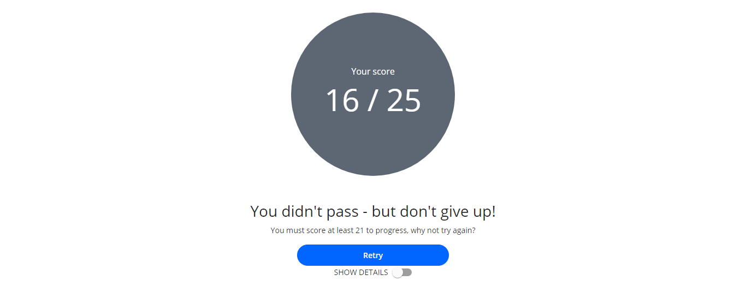

15 OneFile Section 1 Not Passed

You may at this point review your results by selecting show details.

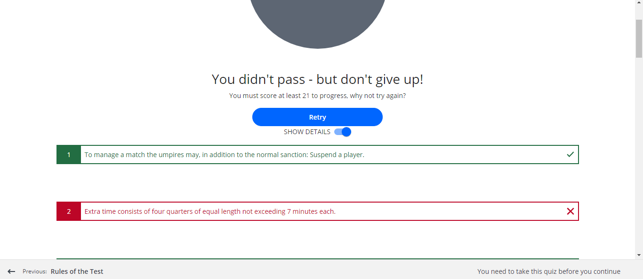

16 OneFile Show Details Screen
This screen shows which questions you got right, and which ones were wrong. It doesn’t state whether the answer was True or False, just if you were correct or incorrect.

Remember that during your review of the answers the countdown clock is still running

After reviewing your answers, you can either select Retry to attempt the paper again or logout, contact the Administrator and try again later. In the second case the Administrator will allocate you a different paper.

If you elect to retry the paper, you will be presented with the same 25 questions, but they will appear in a different order. The visible countdown clock will reset to 30 minutes.

If successful in retrying Section 1 you will be able to continue onto Section 2. If unsuccessful in retrying Section 1 you will need to reapply through your country’s process.

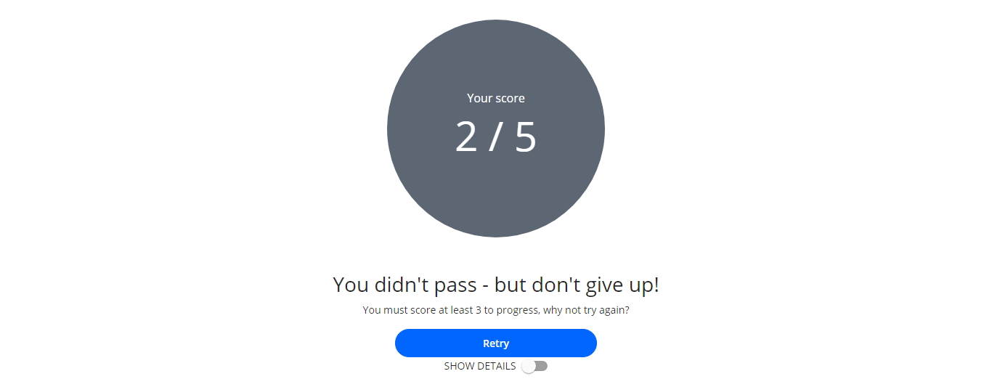

17 Section 2 Not Passed
Again, you may review your answers by selecting SHOW DETAILS.

Press Retry, which is recommended, or log out, contact the Administrator and try again later. In the second case the Administrator will allocate you a different paper and you will have to retake both Sections again.

Please note that if you Retry Section 2 the clock DOES NOT reset to 30 minutes, it continues to count down.

You get 2 strikes, failure in either Section classes as 1 strike. If unsuccessful in 2 Sections, then you will have to reapply through your Country’s website to take the Online Paper again.

Return to top
Hints and Tips

Forgotten Password

If, on leaving and re-entering OneFile, you forget your password there is a Forgot Password button on the login page.

18 Forgot Password Screen

Section 1 Questions

Read each question carefully. Look for key words such as must, may, should or can, for example. All questions are carefully worded using, where possible, the exact wording in the Rule Book.

Does the rule book say, “The umpire may…” but the question says, “The umpire must…”? as these are different, then the answer would be False.

Section 2 Questions

In here each question has 3 possible answers but only 1 of them is correct. Carefully read each question and then all 3 options. Look out for the team colours to make sure you do not select the wrong option. Have you selected the correct sanction? Is it a free pass or a penalty pass?

General

There are no trick questions.

Do not consider any factor not mentioned. If an action isn’t written in the question, then it isn’t relevant.

Large Print

Some learners may require large print. This can be achieved by holding down the CTRL key and press the + key to increase the letter sizes and – key to decrease the letter sizes.

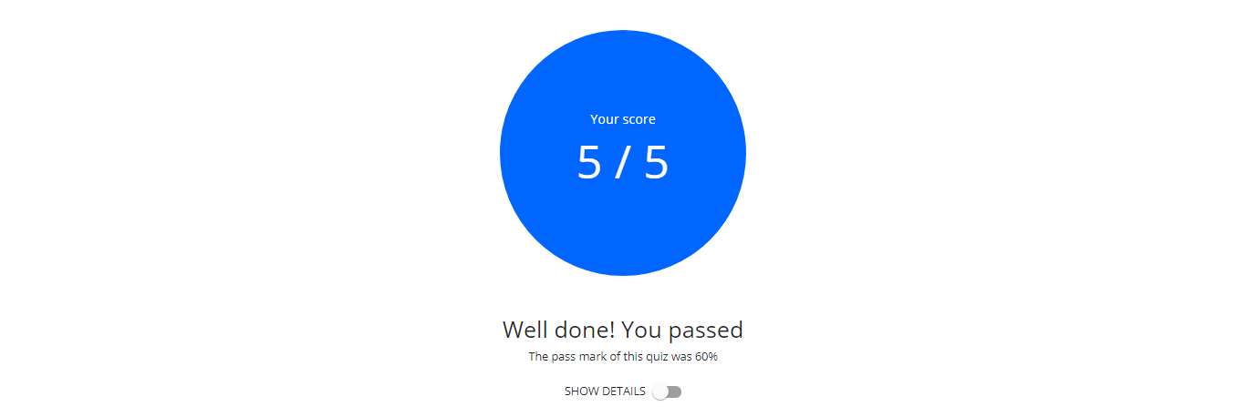

19 OneFile Normal Letter Size

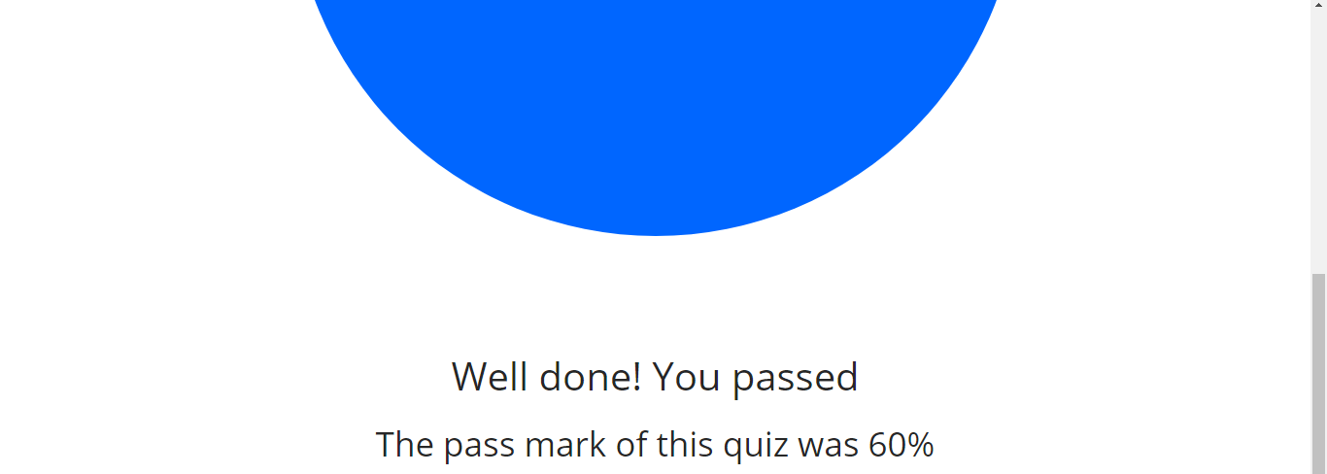

20 OneFile Increased Letter Size

Return to top

