Feedback and Complaints-Essex Metropolitan Netball Association

If you wish to raise a concern or complaint or need help deciding where to refer your concern or complaint, contact our Resolution Lead who will look to seek a resolution or provide advice.

Resolution Lead: Tania Legore
Resolution Lead contact details: t_legore@hotmail.com 07960 761180

Types of Complaint
- Safeguarding concern
- Competition Rules complaint
- Service provision complaint
- Code of Conduct breach

The resolution procedure for a complaint has two potential stages: informal and formal. Unless serious, it is always preferable to seek to resolve a complaint through informal resolution stage at a local level.

Informal Stage
All complaints, unless of a serious nature, relating to competition rules and regulations or provision of services by England Netball, London & the South East Region Netball Association, Essex Metropolitan Netball Association or a club within Essex Metropolitan, should try to be resolved informally at a local level. Please contact our Resolution Lead on the details above.

Formal Stage
If a problem cannot be resolved informally, if the issue involves allegations of serious misconduct, or the complainant wishes for the matter to be handled formally, the complaint should be handled under the formal process and the Appropriate Authority and relevant policy identified.

If a complaint is to progress to a formal stage, the relevant Appropriate Authority and correct policy under which to handle the complaint are set out in the flowchart below.

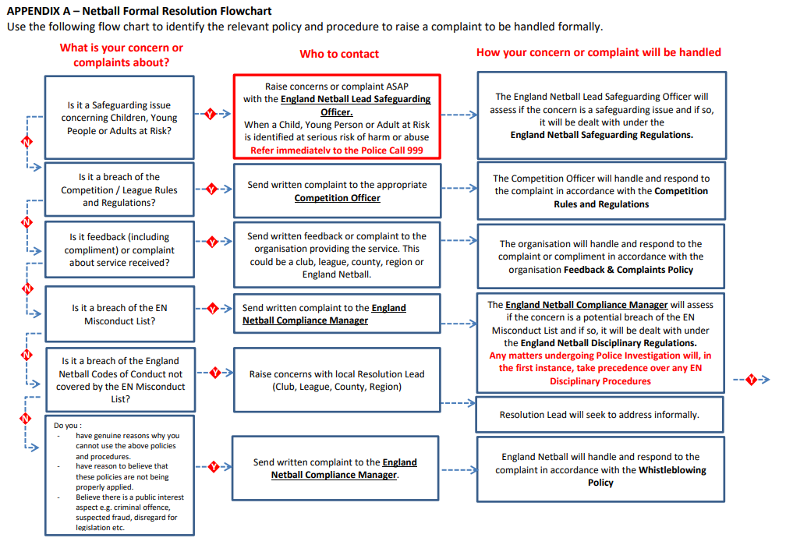Key Contacts
England Netball | Region | County | League/Competition
Lead Safeguarding Officer  besafe@englandnetball.co.uk  01509 277911 | Region Resolution Lead  Tania Legore  t_legore@hotmail.com  07960 761180  London & South East Region Regional Coordinator  Lucy Goodman  Lucy.Goodman@englandnetball.co.uk  020 7993 4709 | County Resolution Lead  Tania Legore  t_legore@hotmail.com  07960 761180 | - Essex Met League  - Junior League  County Resolution Lead  Tania Legore  t_legore@hotmail.com  07960 761180  - National Schools  Schools Secretary  Sonia Adams  soniamadams@live.com  07956 439380
Compliance Manager
complaints@englandnetball.co.uk
01509 277911

September 2023

