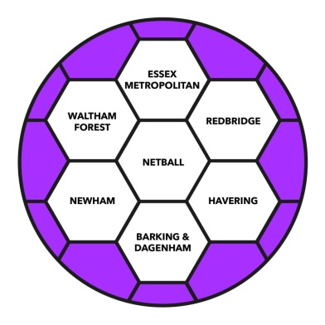

**ESSEX MET COUNTY NETBALL ASSOCIATION AGM**

Publicity

I am stepping away from this role for the next year. The application is available via the website. Thank you to the committee for being very welcoming, I have enjoyed my time and I am sorry to be stepping away!

Olivia

|  |  |
| --- | --- |
| Image result for website icon | **Website**  Essex Met Website is updated regularly with news, courses and background information.  Visit us: <http://www.essexmet.co.uk/> |
| *Image result for facebook page icon* | **Main Facebook Page: Essex Met**  776 followers up from 653 last season  <https://www.facebook.com/EssexMet/>  The Facebook page is our main ‘hub’ for communication in parallel with the website. This season particularly it has become a go to place for teams looking for umpires.  Facebook Group: Essex Met League Discussion Page  Now has 970 members, we implemented group rules for this group and updated the name to avoid confusion when posts were coming for the Exec committee or members of the league. |
| Image result for instagram logo | **Instagram: @netballinEssexMet**  704 followers (created & run by England Netball NDO)  <https://www.instagram.com/netballinessexmet/?hl=en> |
|  |  |